Name: ________________________
Date: _____________ Block: _____
Why are there different sects in Islam?
Vocabulary
Sect – a group of people with somewhat different religious beliefs from those of a larger group to which they belong.
Caliph – the chief Muslim civil and religious ruler, regarded as the successor to Muhammad.
Ayatollah – A Shia religious leader in Iran.
Heretic – a person holding an opinion at odds with what is generally accepted by the larger group.
Predominantly – mainly; for the most part.
Geopolitics – politics, especially international relations, as influenced by geographical factors.

Part 1
Directions:
Watch the following YouTube videos and complete a Venn Diagram comparing and contrasting Sunni Islam and Shia(Shiite) Islam. Be sure to list countries that are predominantly Sunni and countries that are predominantly Shia. Also list political groups and leaders that are Sunni or Shia.
Sunni vs. Shia – Differences and Conflicts Explained – 3:57
https://www.youtube.com/watch?v=tQdhmsw-hvc
Breaking down the conflicts between Sunnis and Shiites – 4:39
https://www.cbsnews.com/news/in-detail-sunnis-vs-shiites/
https://www.youtube.com/watch?v=pQMpcSQIvOk
Sunni and Shia Islam Part 1 – Khan Academy – 8:12
https://www.youtube.com/watch?v=iMbAu2Oh7PA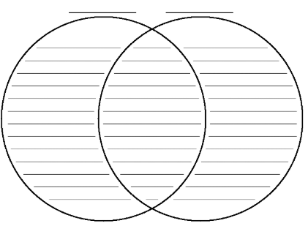

Part 2
Directions:
Answer the following questions with complete sentences:
- Do you think the conflicts between Sunni and Shia Muslims will ever be resolved? Why or why not?

- If you were to tell someone else the 3 most important facts to know about sects in Islam, what would you tell them? Summarize in 3 sentences.

