Name: ________________________________
Date: ___________________ Block: _______

The Gothic Cathedral – Construction, Significance and Enduring Symbolism

Why has the burning of Notre Dame touched so many greatly? Because we believe in beauty, majesty, faith, art, history, and the human expressions thereof. We recognize in this magnificent edifice our common humanity. A scar has now emerged in our connections to our past, our future, and each other.
Standing in Notre Dame, one couldn't help but look in awe at the creations of the human mind and reflect on the toil of the human body. The scale and craft rightfully draw people from around the globe.
Dan Rather, April 15, 2019

In consideration of the news from Paris last week, we are going to take a more in-depth look at the construction of a Gothic cathedral – its purposes, challenges, and characteristics. Then you will read an article about the cathedral of Notre Dame and make connections to what you learned from David Macaulay’s Cathedral movie.

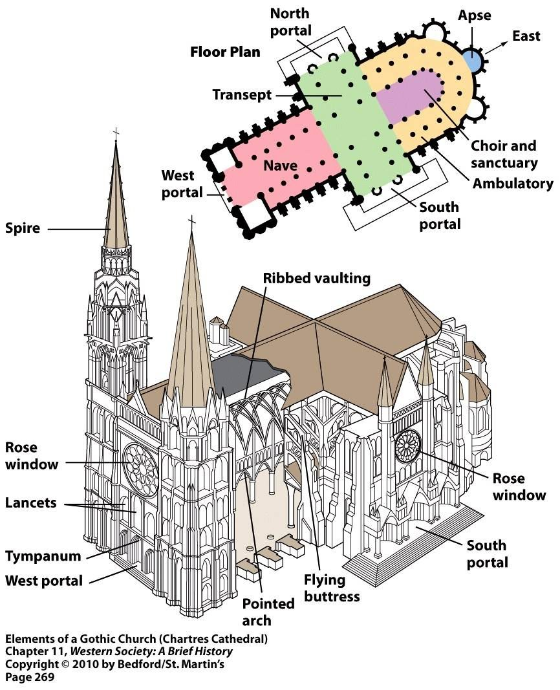

David Macaulay’s Cathedral Video Notes:

Purpose of cathedral | Characteristics of cathedrals
Challenges of cathedral construction | Other:

