Name: _________________________________
Date: ____________________ Block: _______

RISE OF FEUDALISM

Self-sufficiency
government
Christianity
peasants
manor
lords
king
rural
Rome

In feudalism, land and loyalty were given in exchange for services, such as fighting in wars or farming the land.

Why did the system of feudalism develop?

To create order and safety;

FEUDAL GLOSSARY:
fief – land granted to vassal by lord
rural - countryside
self-sufficient – produce all you need to live
vassal – noble or knight who serves a higher lord

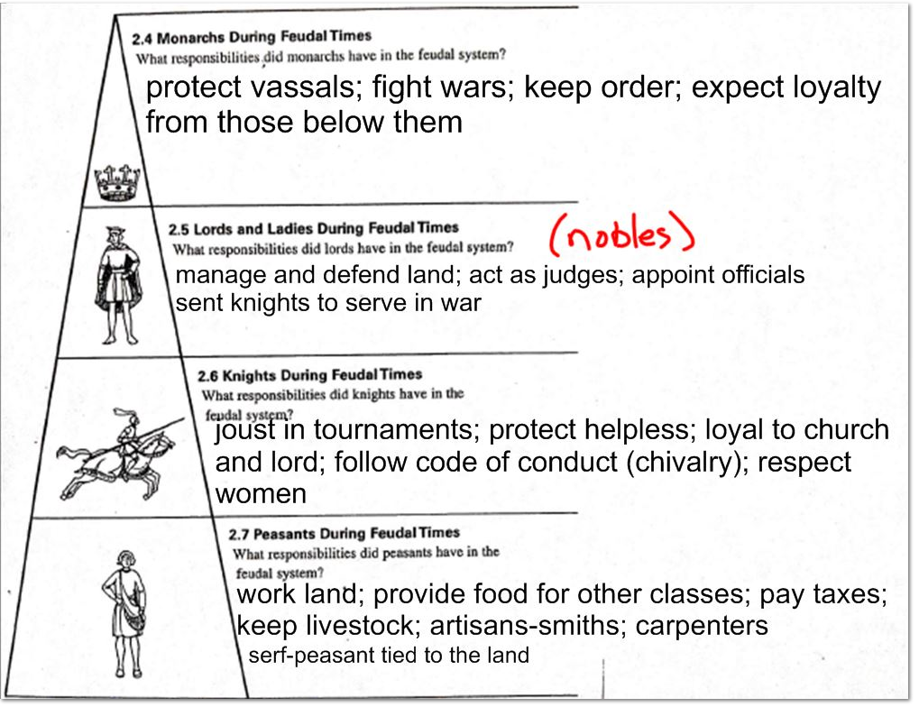

Which class on this social pyramid had the most important responsibilities? Why?

