Effects of the Trans-Atlantic Slave Trade
Name:
Date:
Block: #18

Historical Context:

As all the Kings, Explorers and business financers had hoped, the Americas were full of opportunities to make money. Gold, silver and other minerals could be mined, and tobacco, sugar and other crops could be grown on plantations. In order to make use of these resources there would have to be a reliable supply of laborers to do the work. The Native American population had dwindled due to disease and war and did not provide enough labor. However, the Europeans had access to another cheap labor market that already existed, the African Slave Trade. While the use of slaves has existed in societies for millennia, it was not until the mid-fifteenth century that Europeans began trading and capturing slaves from the African continent, just in time for the discovery of the Americas... Between 1450 and 1870 over ten million humans were taken from Africa. This would have enormous consequences for both the African and American continents and for all the people involved, especially the slaves themselves.
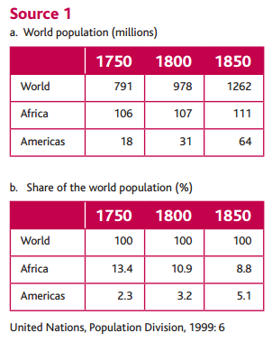
What happened to Africa’s population in chart a? Did it increase at the same rate as the world or the Americas? Explain.

What happened to Africa’s share of the world population over time? Why do you think this was the trend?

Source #2:
The influence of Europe during the era of the slave trade left a permanent mark on every [African] community it touched: some flourished, others disintegrated. | Based on this quote, what happened to African communities? Why did it happen?
Source #3: - from Volume 1 of J.H. Bernardin de Saint Pierre’s Voyage to the Isle de France, Isle de Bourbon, The Cape of Good Hope… (1773)
“I do not know if coffee and sugar are essential to the happiness of Europe, but I do know well that these two products have accounted for the unhappiness of two great regions of the world: America has been depopulated so as to have land on which to plant them; Africa has been depopulated so as to have the people to cultivate them.” | According to this passage, what has happened in the Americas?  What has happened in Africa?

Source #4: Klein: 1999
Trading was profitable at the level of the individual, group, or class doing the trading. But what about the social costs of the trade? The slave raids against farmers and the abandonment of good crop lands, the stress on defense or military activity, the draining of young adults from the labor force, all had their long-term economic costs. | What concerns does the author raise about the impact of slave trade? List 3 reasons in your own words.

Source #5: King Afonso I of Kongo, Letter to King Jao of Portugal, 1526.
Our country is being completely depopulated, and your Highness should not agree with this nor accept it as in your service. And to avoid it we need from (you) no more than some priests and a few people to teach in the schools, and no other goods except wine and flour for the holy sacrament. That is why we beg of Your Highness to assist us in this matter, commanding your factors that they should not send here either merchants or wares, because it is our will that in these Kingdoms there should not be any trade of slaves nor outlet for them…  Moreover, Sir, in our Kingdoms there is another great inconvenience which is of little service to God, and this is that many of our people, keenly desirous as they are of the [trade goods] of your Kingdoms, which are brought here by your people, and in order to satisfy their [greedy] appetite, seize many of our people, free and exempt men; and very often it happens that they kidnap even noblemen and sons of noblemen, and our relatives, and take them to be sold to the white men who are in our Kingdoms… | What does King Afonso want from the Portuguese King? (name at least 2 requests)  What is King Afonso upset with in this paragraph? Why do you think?

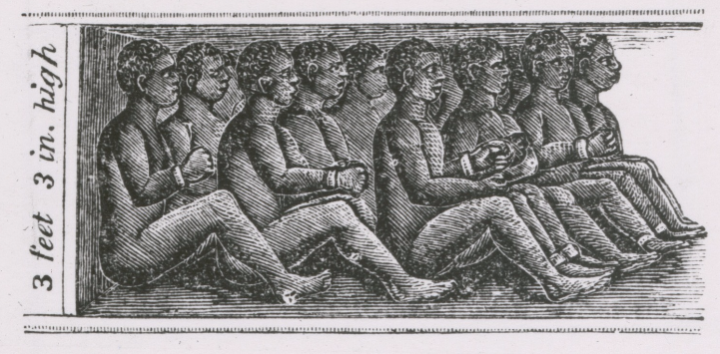
Source #6: “View of chained African slaves in cargo hold of slave ship, measuring three feet and three inches high.” Digital Public Library of America
What is this diagram showing? What does this tell you about conditions on the slave ship?

Source #7: Olaudah Equiano, Autobiography, 1789.
The stench of the hold while we were on the coast was so intolerably loathsome, that it was dangerous to remain there for any length of time, and some of us had been permitted to stay on the deck for the fresh air; but now that the whole ship's cargo were confined together, it became absolutely [harmful.] The closeness of the place and the heat of the climate, added to the number in the ship, which was so crowded that each had scarcely room to turn himself, almost suffocated us. This produced [much] perspiration, so that the air soon became unfit for respiration from a variety of loathsome smells, and brought on a sickness amongst the slaves, of which many died.  This wretched situation was again [worsened] by the [adhesion] of the chains, now become insupportable, and the filth of the necessary tubs, into which the children often fell, and were almost suffocated. The shrieks of the women, and the groans of the dying, rendered the whole scene of horror almost inconceivable. | In general, what is being described in this document? (two words)  List at least 5 aspects of this experience that Equiano describes.

Source #8: Triangular trade
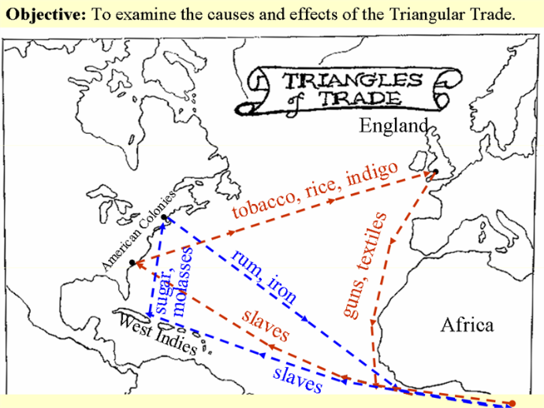
Describe how triangular trade worked. There are two triangles shown on this map – describe both.

