DAY 3 - Tuesday, May 27:
1. Finish following Friday’s directions, including: 1. Complete your research/notes (phrases, own words, keep track of websites.) 2. Write intro paragraph on Word doc then proofread and post on Edmodo. 3. Replies reminders:
a. As other people post, read their introductions. Look for individuals that you can ask questions of or find people you have similarities to / connections with.
b. Reply to a minimum of 3 posts (as in, that’s not enough for an A). Remember:
a. Replies MUST be 1-2 full, proofread sentences and show that you have read the person’s post and are giving a thoughtful reply.
c. Help out your classmates – if people don’t have any or many replies, please notice this and reply to them with a thoughtful question or comment.
d. I will critique original posts – there is no need for your reply to tell the author that they spelled something wrong or are missing some required fact.
e. Replies that are not full sentences (you know, start with a capital letter, end with punctuation and have all the other right parts in between…) will lose points. Replies such as “that’s cool” or “me, too” take up extra space on the wall and do not contribute to the discussion. Such short meaningless replies will lose points as they make it harder for your peers to look through posts to see who has replies and who doesn’t.
f. Remember that you’ll have to click “show more” at the bottom of the screen as all posts and replies will not fit on one page.

This isn’t Facebook. This is a graded assignment.
2. Finish the research needed about your individual’s greatest challenge.
3. On your word document, write a 3-5 sentence explanation identifying the biggest challenge and how your individual dealt with it/what the outcome was. Remember, you’re still writing from your individual’s perspective. Make sure it’s in your own words. Plagiarism=ZERO!
4. After your challenge entry is written and proofread, log on to Edmodo.
5. In Edmodo, look for your introduction that you posted to the wall.
6. Look for the drop down arrow to the right of your post.
7. Select “edit post”. Copy your challenge sentences from the word document and paste them under your introduction statement.
8. Save changes.
9. Check to make sure your post now has both your introduction and challenge statements.
10. It should look something like this:
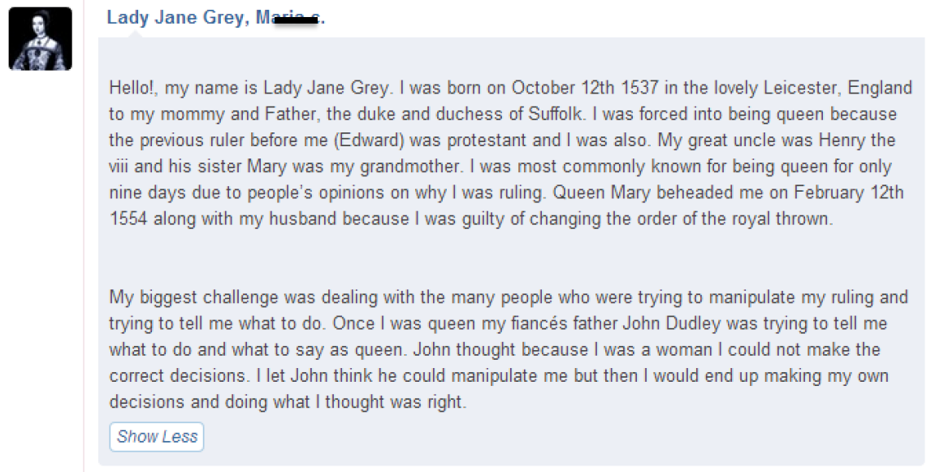

11. Finish/reply to questions or comments that have been left on your original post.
12. If you have time left, please make sure all previous parts of this project are caught up.

