Annotated Bibliographies
Definitions
A bibliography is a list of sources (books, journals, websites, periodicals, etc.) one has used for researching a topic. Bibliographies are sometimes called "references" or "works cited" depending on the style you are using. A bibliography usually just includes the bibliographic information (i.e., the author, title, etc.).

An annotation is a summary and/or evaluation. Therefore, an annotated bibliography is a citation which includes a summary and/or evaluation of each of the sources.
- Summarize: Some annotations merely summarize the source. What are the main arguments? What is the point of this book or article? What topics are covered? If someone asked what this article/book is about, what would you say? The length of your annotations will determine how detailed your summary is.

- Assess: After summarizing a source, evaluate it. Who is the author of the source and is he/she an expert in the field? How does it compare with other sources in your bibliography? Is the information reliable? Is this source biased or objective? What is the goal of this source?

Sample of a well written annotation:
Ehrenreich, B. (2001). Calcutta: pollution and health. (2009) [Television broadcast]. CBS. Retrieved from
www.cbsnews.com.
Ehrinreich is the author of a CBS News story about the devastating pollution in Calcutta, India. The story was developed from research carried out by a team of qualified academics from the School of Environmental Studies at the Jadavpur University in India. Ehrinreich’s research team conducted its studies between 2003 and 2005. The content covers air pollution, specifically the content of heavy metals in the air, and sound pollution. The information is supported with numerous graphs. Ehrinreich holds a PhD in Environmental science and Biology, as well as a master’s degree in Microbiology.
Sample of a poorly written annotation:
Ehrenreich, B. (2001). Calcutta: pollution and health. (2009) [Television broadcast]. CBS. Retrieved from www.cbsnews.com
This was a good site about air pollution in Calcutta, because it had a lot of good information for my topic. I liked this site. It has more specific information than books and is not too much to read. It is authoritative because it is up to date and all rights are reserved.

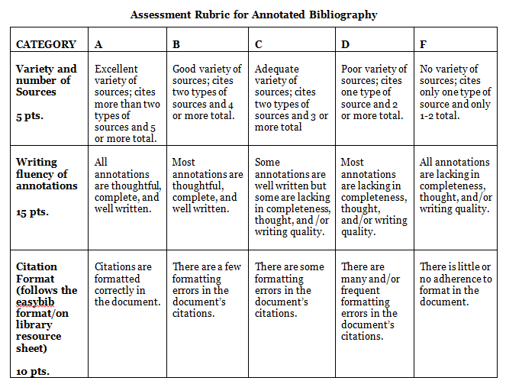
  - Write citation in correct format. Remember to indent after the first line (reverse of a paragraph.)
  - Use the notes on your resource page to write the annotation summary/analysis.
  - Remember: No “I” statements.

